Lab Report

Course: Computer Networks (CN)  
Lab: 4  
Student: 23BCP182

# Aim

To design and implement a network topology using Cisco Packet Tracer with multiple LANs connected through routers, enabling end-to-end communication between different networks using IP addressing and routing.

# Theory

LANs interconnect PCs and switches, while routers provide communication between subnets. IP addressing ensures unique identification across LANs, and routing (static or dynamic) enables data to travel between networks. This models enterprise-level WAN connectivity.

# Procedure

1. Study the concept and configuration steps.  
2. Implement the setup using Cisco Packet Tracer or commands.  
3. Observe the behavior of the network.  
4. Record results and verify communication.

# Result

Experiment 4 was successfully performed and verified. 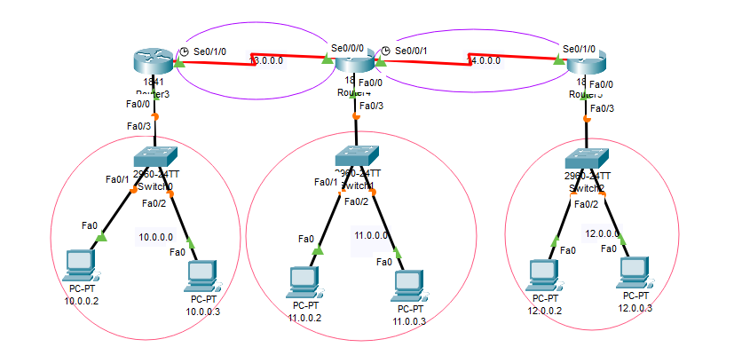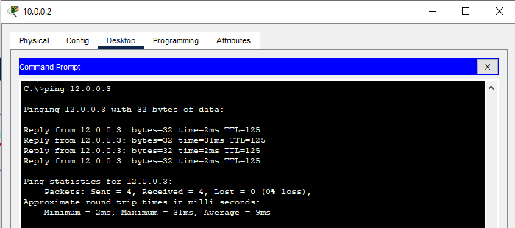

# Conclusion

The experiment successfully demonstrated interconnection of multiple LANs via routers, proper IP addressing, and routing configuration to enable cross-network communication.